Station 1
Compositions & Inverses of Functions

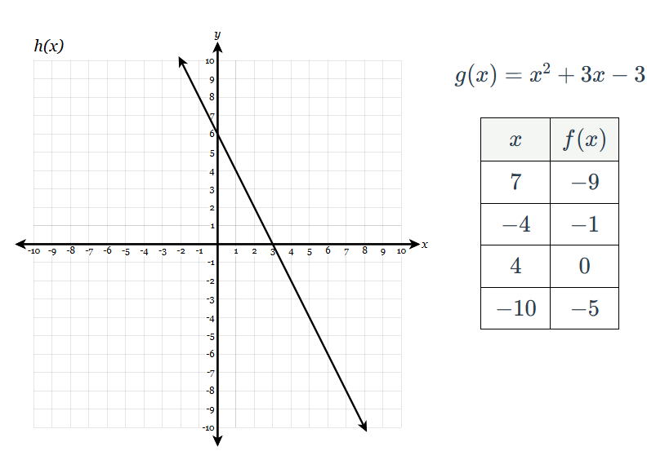
Use the representations of $h(x), g(x)$ and $f(x)$ to complete #s 1-7.
- Evaluate. $f(7)∙h(2)$
- Evaluate. $h(f(-4))$
- Evaluate. $g(h(3))$
- Evaluate $h(f^{-1}(0))$.
- If $g(x)=1$, what is(are) the value(s) of $x$?
- If $f(h(x))=0$, what is the value of $x$?
- If $k(x)=x+2$, what is $g(k(x))$ in standard form?

- Find the inverse of $f(x)=7(\frac{x^{1/3}}{6}+5)$.
- Given $f(x)=9(\sqrt[5]{x}-8)+10$, find $f^{-1}(x)$.

Station 2
Analyzing Graphs

Identify the following characteristics, if possible, of each function.
- Function type
- Domain
- Range
- End behavior
- Increasing interval(s)
- Decreasing interval(s)
- Positive interval(s)
- Negative interval(s)
- Intercepts
- Asymptote(s)

$f(x)$  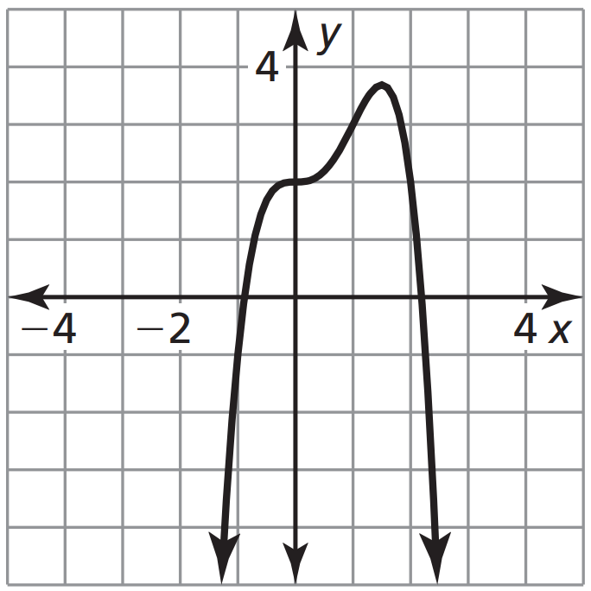 | $g(x)$  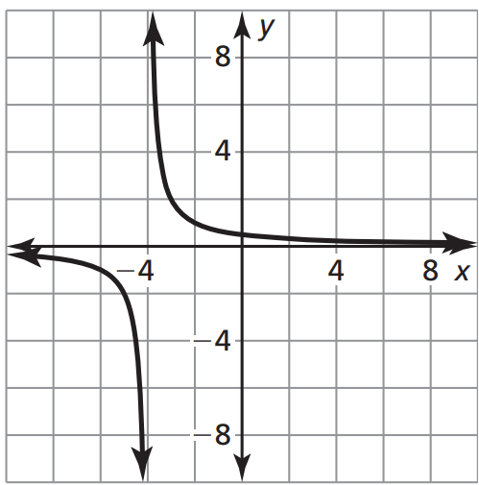
$h(x)$  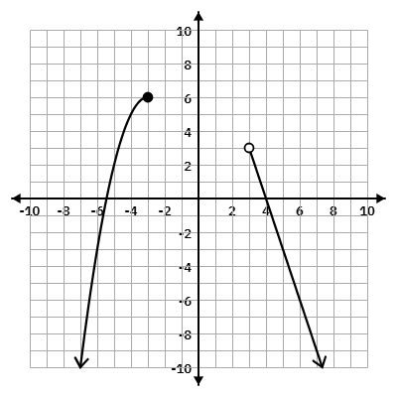 | $j(x)$  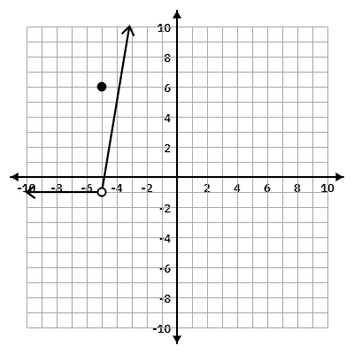

Station 3
Factoring

Factor completely.
- $x^{4}-x^{4}y^{4}$
- $x^{4}-16$
- $x^{4}+4x^{2}+3$
- $36-x^{6}$
- $144x^{2}-y^{6}$
- $x^{4}-10x^{2}+16$
- $6x^{2}-25x+25$
- $48x^{8}-27$
- $4x^{4}-32x^{3}+48x^{2}$
- $x^{3}+4x^{2}-9x-36$
- $4x^{2}+31x+21$
- $2x^{2}+7x+5$
- $-2x-x^{5}+3x^{3}$
- $50x^{10}-18x^{2}$
- $-2x^{2}-22x-60$
- $x^{3}+7x^{2}+x+7$
- $x^{3}-x^{2}-2x$

Station 4
Solving Equations, Inequalities & Systems

Solve. Check for extraneous solutions, when necessary.
- $-\frac{1}{2}x+3=-5-\frac{1}{2}(9x+1)$
- $x^{2}-2x-28=-6x+4$
- $x^{2}-13x+30≥0$
- $-4x^{2}-10x+9=-6x^{2}$
- $5x^{2}+x-2=0$
- $-3x^{3}+4x^{2}-12x+16=0$
- $3x^{2}-33x+76<4$
- Calculator Active. Round to the nearest thousandth. $1.7x^{2}-5x-1.4=0$
- $-9x+6y+4z=-10$
$-9x+5y+4z=-8$
$9x+y-3z=1$

Station 5
Evaluating Trigonometric & Logarithmic Expressions

Evaluate. When necessary, write answers in simplest, exact form with a rational denominator.

- $log_{5}5$  - $log_{2}128$  - $sin(\frac{5π}{6})$  - $log_{4}\sqrt[3]{4}$  - $ln(e)$  - $tan(\frac{5π}{4})$  - $log_{4}(-4)$  - $log_{5}\sqrt[5]{625}$  - $secπ$  - $log_{7}\frac{1}{7}$ | - $csc\frac{2π}{3}$  - $log_{64}\frac{1}{8}$  - $sec\frac{3π}{4}$  - $log_{25}5$  - $log_{4}\frac{1}{2}$  - $log_{81}27$  - $cos\frac{3π}{2}$  - $cot\frac{π}{6}$  - $tan\frac{π}{2}$  - $sin(-\frac{11π}{6})$

Answer Key

Station 1
- -18
- 8
- -3
- -2
- -4 or 1
- 1
- $x^{2}+7x+7$
- $f^{-1}(x)=(6(\frac{x}{7}-5))^{3}$
- $f^{-1}(x)=(\frac{x-10}{9}+8)^{5}$
Station 2
$f(x)$
- Polynomial
- All Real #s
- $-∞<y≤3.75$
- As $x→∞$, $f(x)→-∞$
As $x→-∞$, $f(x)→-∞$
- $-∞<x<1.5$
- $1.5<x<∞$
- $-0.9<x<2.1$
- $-∞<x<-0.9$ or $2.1<x<∞$
- X-Intercepts at approximately $(-0.9,0)$ and $(2.1,0)$; y-intercept at $(0,2)$
- None

$g(x)$
- Rational
- All Real #s except -4
- All Real #s except 0
- As $x→∞$, $g(x)→0$
As $x→-∞$, $g(x)→0$
- None
- $(-∞,-4)∪(-4,∞)$
- $(-4,∞)$
- $(-∞,-4)$
- No X-intercept; y-intercept at approximately $(0,0.5)$
- HA at $y=0$ and VA at $x=-4$

$h(x)$
- Piecewise
- $(-∞,-3]∪(3,∞)$
- $(-∞,6]$
- As $x→∞$, $h(x)→-∞$
As $x→-∞$, $h(x)→-∞$
- $(-∞,-3)$
- $(3,∞)$
- $(-5.5,-3]∪(3,4)$
- $(-∞,-5.5)∪(4,∞)$
- X-intercepts at approximately $(-5.5,0)$ and $(4,0)$; no y-intercept
- None

$j(x)$
- Piecewise
- All Real #s
- $[-1,∞)$
- As $x→∞$, $j(x)→∞$
As $x→-∞$, $j(x)→-1$
- $(-5,∞)$
- None
- $(-4.8,∞)$
- $(-∞,-4.8)$
- X-Intercepts at $(-4.8,0)$; y-intercept at $(0,29)$
- None

Station 3
- $-x^{4}(y^{2}+1)(y-1)(y+1)$
- $(x^{2}+4)(x+2)(x-2)$
- $(x^{2}+3)(x^{2}+1)$
- $-(x^{3}+6)(x^{3}-6)$
- $(12x-y^{3})(12x+y^{3})$
- $(x^{2}-8)(x^{2}-2)$
- $(3x-5)(2x-5)$
- $3(4x^{4}+3)(4x^{4}-3)$
- $4x^{2}(x-6)(x-2)$
- $(x+3)(x-3)(x+4)$
- $(4x+3)(x+7)$
- $(2x+5)(x+1)$
- $-x(x+1)(x-1)(x^{2}-2)$
- $2x^{2}(5x^{4}-3)(5x^{4}+3)$
- $-2(x+5)(x+6)$
- $(x^{2}+1)(x+7)$
- $x(x-2)(x+1)$
Station 4
- $x=-\frac{17}{8}$
- $x=-8$ and $x=4$
- $(-∞,3]∪[10,∞)$
- $x=\frac{5±\sqrt{7}}{2}$
- $x=\frac{-1±\sqrt{41}}{10}$
- $x=\frac{4}{3}$ and $x=±2i$
- $3<x<8$
- $x≈-0.257$ and $x≈3.199$
- $x=2,y=-2,z=5$

Station 5
- 1
- 7
- ½
- ⅓
- 1
- 1
- Undefined
- ⅘
- -1
- -1
- $\frac{2\sqrt{3}}{3}$
- -½
- $-\sqrt{2}$
- ½
- -½
- ¾
- 0
- $\sqrt{3}$
- Undefined
- ½

